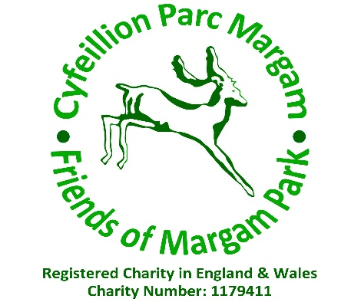

Friends of Margam Park Volunteer Policy

Introduction

The Friends of Margam Park exist to support and add value to the services provided at Margam Country Park. To this end the Friends of Margam Park seek to involve volunteers to help with:
- Our activities' programme
- Manning the Friends of Margam Park room
- Conducting castle tours
- Assisting with deer feeds
- lead a variety of walks around the park
- Assisting with the Park's organised events such as the Dinosaur Day and Jousting.
- Compiling the history of the Park and organising the Archive room.
(This list is not exhaustive and is always subject to change and new additions).

Principles

The Friends of Margam Park will ensure that volunteers are properly integrated into the organisational structure and that mechanisms are in place for everyone to contribute to the Friends of Margam Park ventures.
- Our volunteers are not replacements for paid staff.
- The Friends of Margam Park expects that staff at all levels will work positively with volunteers and where appropriate, will actively seek to involve them in their work
- The Friends of Margam Park recognises that volunteers require satisfying work and personal development and will seek to help volunteers meet these needs as well as seeking training for them to do their work effectively from whatever sources are available.
- Any volunteer of The Friends of Margam Park will not undertake to organise any project under the group's name without prior consent and agreement from the Trustees.
- As a minimum all volunteers will wear the Friends of Margam Park lanyard when working on behalf of the group. This is provided free of charge. There is also clothing available to purchase. (Please see the enclosed leaflet).
- All volunteers must always act in the best interests of the group and as such must be careful when engaging with social media so that the activities of the group and the Park are not brought into disrepute.

- Any grievances or complaints must be brought to the attention of the trustees who will investigate everything carefully. We aim to identify and resolve problems at the earliest possible stage.
- As a volunteer you will be dependable and recognise the commitment to your volunteer assignment or project. Look at assignments that are consistent with your interest, abilities and available time. Be a team player and value the input and suggestions of your fellow volunteers.

Recruitment

Anyone wishing to volunteer will be offered the opportunity of chatting with one of the Friends to find out what they would like to do, the skills they might offer and how best their potential might be realised.

Induction and training

All volunteers will receive an induction into the Friends of Margam Park and their own area of work. Training will be provided as appropriate.
Examples of this are First Aid, dealing with and entering any donations received into the ledger, answering queries from visitors, training as walk leaders (health walk, wildlife walks, Nordic walking), training in recognising the enormous variety of wildlife (deer, birds, reptiles) that can be found in the park, castle tours, use of the radios, emergency procedures.

Expenses

All volunteers will have valid expenses reimbursed, provided this has been agreed in advance by the trustees. This does not include petrol or travel expenses to and from the Park to carry out your usual volunteer duties. Tea, coffee and biscuits will be provided in the Friends' room.

Ideas
The Trustees always welcome new proposals and ideas to enhance the work of the Friends. There are various ways of communicating your ideas from email to a Trustee or the information Officer or through soon to be technical forums. There are also various informal meetings throughout the year that are open to all members. If you have an idea, please share it.

Insurance

All volunteers are covered by The Friends of Margam Park insurance policy, a hard copy of which can be found in the Friends' room. All volunteers are covered whilst they are on the park premises and engaged in any work on the Friends of Margam Park's behalf. To this end, lanyards must be worn.

Health and Safety

All volunteering tasks undertaken by the Friends of Margam Park volunteers must be risk assessed before any volunteering activity commences. Provision will be put in place wherever possible to minimise any potential harm to volunteers. All volunteers will be briefed of the health and safety aspects of their tasks before embarking upon any activity. All volunteers are expected to follow all safety arrangements to minimise any potential risk to themselves and others who may be affected by their acts or omissions.

Equal Opportunities

The Friends of Margam Park are committed to equal opportunities and believes that volunteering with the Friends should be open to all regardless of age, gender, race, disability, pregnancy (and maternity leave), sexual orientation, religion and belief, and marriage and civil partnership. Young people under the age of sixteen may volunteer providing they are supervised and accompanied by an adult. The Friends of Margam park will not tolerate discrimination in any way in respect to volunteers. Everyone is expected to understand this and commit to the equality’s principle.

Intellectual property
All material, written or produced while engaging in activities for the Friends of Margam Park will be the sole property of the Friends of Margam Park.

I agree to the principals and rules as laid out in this Volunteer Policy

Signed:

Date:

