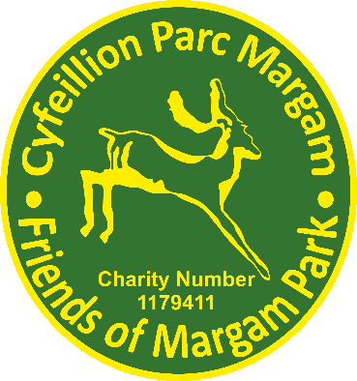
Name: _____________________

Friends of Margam Park

Volunteer Policy

Introduction

The Friends of Margam Park exist to support and add value to the services provided at Margam Country Park. To this end the Friends of Margam Park seek to involve volunteers to help with any of the following activities:

- Our crafts and activities programme
- Staffing the Turbine House and the courtyard visitor’s room
- Conducting castle tours
- Litter picking
- Lead a variety of walks around the park
- Gardening and the restoration of the historic walled garden at Twyn Yr Hydd
- Assisting with the Park's organised events such as the Dinosaur Day, Superhero Day and the Christmas Deer Feeds and any other park events
- Assisting with the compilation of the history of the park and organising the archive room
- Oral history project

(This list is not exhaustive and is always subject to change and new additions.)

Principles

The Trustees of Margam Park will ensure that volunteers are properly integrated into the organisational structure and that mechanisms are in place for everyone to contribute to Friends of Margam Park ventures.
- Our volunteers work compliments the park staff and are not replacements for paid staff.
- The Friends of Margam Park recognises their duty of care to their volunteers and will seek to provide the correct training needs as and when required, leading to a positive and satisfying experience for the volunteer.
- Any volunteer of The Friends of Margam Park will not undertake to organise any project under the group's name without prior consent and agreement from Trustees.
- As a minimum all volunteers will wear the Friends of Margam Park lanyard with photo ID at all times when volunteering on behalf of the group. This is provided free of charge. There is also clothing available to purchase at cost price.

- All volunteers must always act in the best interests of the group and as such must be careful when engaging with social media so that the activities of the group and the Park are not brought into disrepute.
- Any grievances or complaints must be brought to the attention of the trustees through the Friends of Margam Park Grievance Procedure, who will carefully investigate everything. We aim to identify and resolve problems at the earliest possible stage.

Recruitment

Anyone wishing to volunteer will be offered the opportunity to discuss with one of the Friends which activities they may be interested in, the skills they are able to offer and how best their potential might be realised.

Induction and Training

All volunteers will receive an induction into the Friends of Margam Park and their own area of volunteering. Training will be provided where appropriate.

Ideas

The Trustees always welcome new proposals and ideas to enhance the work of the Friends. There are numerous ways of communicating your ideas from email to a Trustees. There are also various informal meetings throughout the year that are open to all members. If you have an idea, please share it.

Insurance

All volunteers are covered by The Friends of Margam Park insurance policy, a hard copy of which can be found in the Turbine House and Courtyard Room. All volunteers are covered whilst they are on the park premises and engaged in any volunteering role.

Health and Safety

All volunteers are expected to follow all safety arrangements put in place to minimise any potential risk to themselves and others, who may be affected by their acts or omissions.

Equal Opportunities

The Friends of Margam Park are committed to equal opportunities and believes that volunteering with the Friends should be open to all regardless of age, gender, race, disability, religion, and belief. Young people between the ages of twelve and eighteen may volunteer providing they are supervised and accompanied by a parent/guardian or an appropriate adult(*). No children under the age of twelve may volunteer. The Friends of Margam park will not tolerate discrimination in any way in respect to volunteers. Everyone is expected to understand this and commit to the equality’s principle.

Intellectual property

All material, written or produced while engaging in activities for the Friends of Margam Park will be the sole property of the Friends of Margam Park.

I agree to the principals and rules as laid out in this Volunteer Policy

Print: _________________________________

Sign: _________________________________

Date: ____________

(*) Appropriate adult In English law, an appropriate adult is a parent, guardian or social

worker; or if no person matching this is available, any responsible person over 18
designated by the parent/guardian in writing.

